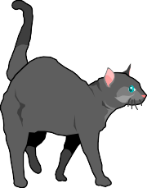

DOG/CAT LICENSES

All dogs/cats 5 months or older are required to be licensed per Village License. Licenses expire December 31 of each year! Any person purchasing a license after March 31 will pay a late fee. Fees are:

Neutered Male Dog/Cat | $10.00
Spayed Female Dog/Cat | $10.00
Unaltered Male Dog/Cat | $20.00
Unaltered Female Dog/Cat | $20.00
Late Fee (Per DOG/CAT) | $20.00

Make checks payable to the VILLAGE OF PALMYRA and enclose the bottom portion of this page. If mailing, send to P.O. Box 380, Palmyra, WI 53156.

DETACH

APPLICATION FOR DOG/CAT LICENSE

Date:

Owners Name

Mailing Address

(Check one)

Sex: Neutered Male
Unaltered Male
Spayed Female
Unaltered Female

Name of Dog/Cat

Breed Color

Date of Rabies Vaccination

Please send your original rabies certificate with this application. Your certificate will be returned to you along with your dog/cat license. No license will be issued without a rabies certificate.

